Airell Rasendriya Bachtiar

airell.bachtiar@student.fontys.nl

Kasintu

Web Collection Game

Project Plan

Semester 3 - Individual Project

Table of Contents

**1.** **Version** 2

**2.** **Introduction** 3

2.1. Definitions, Acronyms, and Abbreviations 3

**3.** **Product Description** 3

**4.** **Planning** 3

**5.** **Product Backlog** 4

**6.** **Risk Management** 10

# **Version**

|  |  |  |
| --- | --- | --- |
| **Version** | **Date** | **Description** |
| 0.1 | 25-02-2022 | Make project plan document, user requirements specification, and test plan. Setup GitHub for the project and initialize code. |
| 0.2 | 25-03-2022 | Make UML Diagram, design document version 1, and applied research document. Prototype application. |
| 0.3 | 14-04-2022 | Design document version 2. Improved applied research document. Prototype application version 2. |
| 0.4 | 13-05-2022 | Design document version 3. Application first release. |
| 0.5 | 3-06-2022 | Final design document. Application second release. |
| 1.0 | 17-06-2022 | Final application release. Web performance review document. |

# **Introduction**

In this project, I, Airell Rasendriya Bachtiar, will make a website game called Kasintu. I will work on this project for an entire semester or 18 weeks.

## Definitions, Acronyms, and Abbreviations

* Gacha: A method inspired by toy vending machine where you can get a toy randomly from what the vending machine provide. Instead of toy vending machine, here it is turned into an application game where you can get an item, in this project we called a creature, randomly with a set number of chances.
* Summon or Pull: The action performed when you are getting a creature from the gacha.
* Banner: The place where you summon or pull creature. Banner contains a list of creatures in which the player can obtained and a chance or percentage of how many chances you can obtain a specific creature.

# **Product Description**

This game is called Kasintu which means bird. Kasintu is a collection-based game where player can collect as much as they want. What they will collect is a different type of birds that is real and fictional thus the meaning of Kasintu is bird, a game where you collect birds. From now on these birds will be called creature.

The main feature of this game is called a gacha system. Gacha system is where player can get a chance to receive a virtual item using in game currency. This is where player mainly get a new creature that will be release or has been released by the developer. They called this action of obtaining new creature as a summoning or pulling. In this case we will call this action as summon or summoning. As the where they summoning these creatures is called a banner. A banner contains a certain amount or all the creature available that can be obtained by the player who summoned on that banner.

For a future feature, Kasintu will also include a marketplace and breeding system. Marketplace is where player can but, sell or trade creatures from the other player. Breeding system is where player can breed their own creature to make new creature which may become rarer that the previous creature.

# **Planning**

This project will last for 17 weeks, and it will be divided into 6 sprints. Every 3 weeks there will be a sprint done where we review what we did on those 3 weeks. If the main feature, which is the gacha system, is done before week 17 timeframe, additional features such as marketplace and breeding system will be implemented. We will be using the agile approach in this project. A meeting will be conducted at least once per sprint.

The first sprint will be mainly for making project plan and test plan. Also, in this sprint, GitHub is set up and a basic application is made. The basic application includes a user object and a couple tests. This basic setup is for setting up continuous integration on GitHub.

On the second sprint, UML diagram, design document, and applied research document should be created. A prototype of the application should be finish. The prototype should include a connection between user interface, the website, and the back end where the data is stored. Previous documents can be changed based on feedback.

On the third sprint, design document and test plan should be improved. On GitHub, SonarQube is implemented for quality assurance. Make a research document. Prototype should be improved as well.

On the fourth sprint, design document should be improved. Make the first release version of the application though it will not be finish. It will demonstrate authentication and authorization. There will be a UX feedback report and based on that, user interface should be improved.

On the fifth sprint, design document should be finish and product backlogs, sprint backlogs, and burn-down charts should be updated. Application should be ready for the second release. Make a security report and implement web sockets in the project.

On the last sprint, all documents should be up to date and final. Make a web performance review document. Application should be ready for the final release.

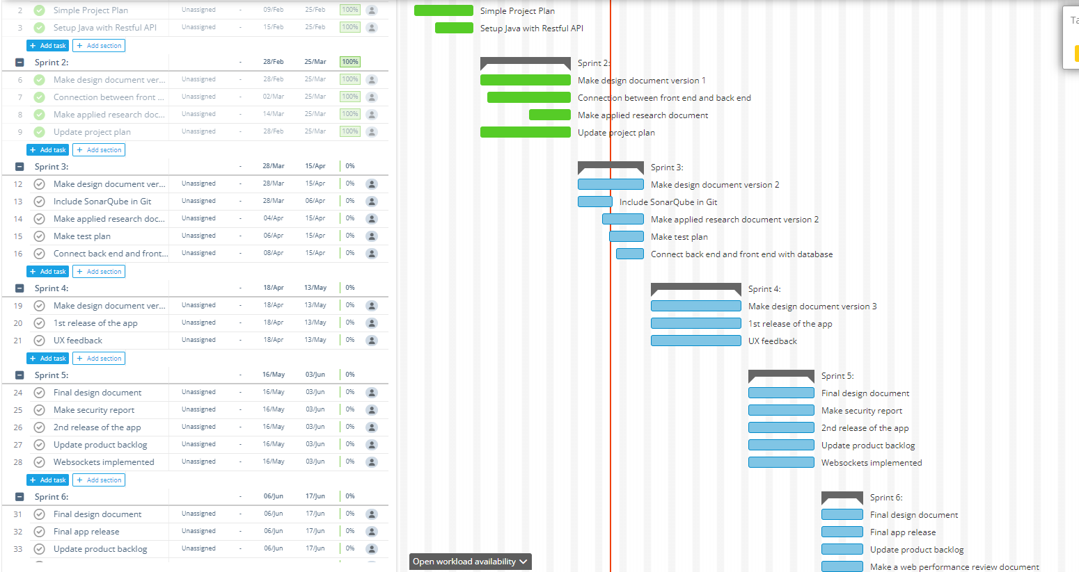

# **Product Backlog**

This section will be sorted based on what you can do after signing up.

Priority and story point will be the range of 1-100.

Main Features:

1. Game Access

|  |  |  |  |  |
| --- | --- | --- | --- | --- |
| **No.** | **User Story** | **Priority** | **Story Point** | **Progress** |
| 1. | **As a** player **I need** to sign-up **so** that I can play the game.  Acceptance Criteria:   * I can insert my email, username, and password * I can switch between sign in page and sign-up page * I can’t leave any input blank for me to sign-up | 60 | 45 | DONE |
| 2. | **As a** player **I need** to sign-in **so** that I can play the game.  Acceptance Criteria:   * I can insert my username and password * I can switch between sign in page and sign-up page * I can login if the username and password is correct and already signed-up | 60 | 43 | DONE |

2. Profile Management

|  |  |  |  |  |
| --- | --- | --- | --- | --- |
| **No.** | **User Story** | **Priority** | **Story Point** | **Progress** |
| 1. | **As a** player **I** **can** edit my profile **so** that other player can see my profile.  Acceptance Criteria:   * I can change my profile description * I can save changes that have been made | 40 | 50 | DONE |
| 2. | **As a** player **I can** change my password **so** that it can be more secured.  Acceptance Criteria:   * I can insert old password to change to a new password * I can insert new password and repeat the new password input * I can’t leave any input blank to change to a new password | 30 | 30 | DONE |

3. Gacha System

|  |  |  |  |  |
| --- | --- | --- | --- | --- |
| **No.** | **User Story** | **Priority** | **Story Point** | **Progress** |
| 1. | **As a** player **I can** *1summon* new creature **so** that I can obtain more creature.  Acceptance Criteria   * I can *1summon* once or 10 times to make summoning faster * I can’t *1summon* if there is no *2banner* available * I have to pay a certain number of coins to be able to *1summon* | 90 | 90 | DONE |
| 2. | **As an** admin **I can** add new creature **so** that player can add it to their collection.  Acceptance Criteria:   * I can add a new creature that was not previously available in the system * I can insert name, rarity, and description of the new creature | 62 | 60 | DONE |
| 3. | **As an** admin **I can** edit creature info **so** that it can be a more suited information in the future.  Acceptance Criteria:   * I can edit creature’s name description or rarity if an old information needed to be change | 55 | 53 | DONE |
| 4. | **As an** admin **I can** delete a creature **so** that it will be deleted from the system.  Acceptance Criteria:   * I can delete an existing creature | 34 | 50 | DONE |
| 5. | **As an** admin **I can** view all creatures available **so** that I can get an overview on all the creatures.  Acceptance Criteria:   * I can see all the creatures available in the system | 60 | 54 | DONE |

*1summon*: summon is an action of getting new creature.

*2banner*: banner is a place where you can summon new creature, usually there are few creatures but not all that are available for you to obtain in each timeframe before the banner itself expired.

4. Inventory Management

|  |  |  |  |  |
| --- | --- | --- | --- | --- |
| **No.** | **User Story** | **Priority** | **Story Point** | **Progress** |
| 1. | **As a** player **I can** view my collection of creatures in an inventory **so** that I can see what I have obtained.  Acceptance Criteria:   * I can see all my creatures that I have been collecting | 85 | 90 | DONE |
| 2. | **As a** player **I can** view individual creature details **so** that I can see what their description is.  Acceptance Criteria:   * I can see creature’s description * I can choose to delete the creature | 76 | 60 | DONE |
| 3. | **As a** player **I can** delete creatures from my inventory **so** that I can delete unwanted creature.  Acceptance Criteria:   * I can delete creature that I own in my inventory * I can choose to confirm deletion so that it can prevent me to delete wrong creature | 57 | 40 | DONE |
| 4. | **As a** player **I can** search creature in my inventory **so** that I can see a more organize inventory  Acceptance Criteria:   * I can search a name of a creature | 65 | 70 | NOT FINISHED |
| 5. | **As a** player **I can** filter creature in my inventory **so** that I can see a more organize inventory  Acceptance Criteria:   * I can filter rarity of a creature | 65 | 72 | NOT FINISHED |
| 6. | **As a** player **I can** sort creature in my inventory **so** that I can see a more organize inventory  Acceptance Criteria:   * I can sort creature alphabetically, descending, and ascending rarity and received order | 65 | 71 | NOT FINISHED |

5. Coin Shop

|  |  |  |  |  |
| --- | --- | --- | --- | --- |
| **No.** | **User Story** | **Priority** | **Story Point** | **Progress** |
| 1. | **As a** player **I can** buy more coin **so** that I can summon more creatures.  Acceptance Criteria:   * I can choose which amount of coin I want to buy * I can confirm buying a coin from the shop | 57 | 43 | DONE |

6. View Player

|  |  |  |  |  |
| --- | --- | --- | --- | --- |
| **No.** | **User Story** | **Priority** | **Story Point** | **Progress** |
| 1. | **As a** player **I can** search other player **so** that I can view their collection and profile info.  Acceptance Criteria:   * I can search player ID to view their profile * If I insert wrong player ID, no result is shown | 68 | 65 | NOT FINISHED |

Additional Features:

1. Marketplace

|  |  |  |  |  |
| --- | --- | --- | --- | --- |
| **No.** | **User Story** | **Priority** | **Story Point** | **Progress** |
| 1. | **As a** player **I** **can** buy creature from the marketplace **so** that I can obtain more creatures.  Acceptance Criteria:   * I can buy any creature in the marketplace if I have enough currency * I can’t buy the creature if another player had bought it earlier than me | 45 | 60 | NOT FINISHED |
| 2. | **As a** player **I** **can** sell my creatures to the marketplace **so** that I can get more currency.  Acceptance Criteria:   * I can sell my creature with as much of currency as I want | 45 | 60 | NOT FINISHED |
| 3. | **As a** player **I can** trade creature with another player **so** that I can get a creature that the other player has in exchange from my creature.  Acceptance Criteria:   * I could trade my creature with another player’s creature if they accepted the offer or accepted our deal * I can trade creatures using currency | 34 | 77 | NOT FINISHED |
| 4. | **As an** admin **I can** cancel a selling creature **so** that I can have more control on the marketplace.  Acceptance Criteria   * I can cancel a buy offer in the marketplace | 32 | 55 | NOT FINISHED |

2. Breeding System

|  |  |  |  |  |
| --- | --- | --- | --- | --- |
| **No.** | **User Story** | **Priority** | **Story Point** | **Progress** |
| 1. | **As a** player **I can** breed 2 creatures **so** that I can get a brand-new creature from the combination of the 2.  Acceptance Criteria:   * I can breed 2 creatures that I own, and the result will be the combination of the 2 * I can’t breed creatures if that creature has a cooldown from the previous breeding * I can get a new creature from breeding 2 unique creatures | 23 | 90 | NOT FINISHED |

3. Friend System

|  |  |  |  |  |
| --- | --- | --- | --- | --- |
| **No.** | **User Story** | **Priority** | **Story Point** | **Progress** |
| 1. | **As a** player **I can** add other player as my friend **so** that I can have easy access of viewing their profile and collection.  Acceptance Criteria:   * I can send a friend request to a designated player based on their ID * I could add a friend if they accepted my friend request | 40 | 78 | NOT FINISHED |
| 2. | **As a** player **I can** accept or decline friend request **so** that I can add them to my friend list.  Acceptance Criteria:   * I can accept a friend request from another player * I can decline friend request from another player | 40 | 80 | NOT FINISHED |

# **Risk Management**

|  |  |  |  |
| --- | --- | --- | --- |
| **Risk** | **Prevention Action** | **Mitigation Action** | **Probability** |
| Don't have enough knowledge to implement a work. | Learn the materials prior to implementing the code. | Ask teachers or friends for help, find the solution on the internet. | 70% |
| Project is behind schedule. | Work on the project before the deadline or earlier. | Work on the project on the weekend and free time just before the deadline or work on it in the next sprint. | 30% |